LAB # 06


Fall 2022
CSE101L Computer Fundamentals Lab

Submitted by: Haris Khan
Registration No. : 60032
Class Section: A

“On my honor, as student of University of Engineering and Technology, I have neither given nor received unauthorized assistance on this academic work.”

Student Signature: ______________

Submitted to:
Engr. Abdullah Hamid
December 15, 2022

Department of Computer Systems Engineering
University of Engineering and Technology, Peshawar

Part#01:
How you will access a Wi-Fi router admin panel attach screenshots of each step.

Step#01:
Click on search below and type “command prompt”.
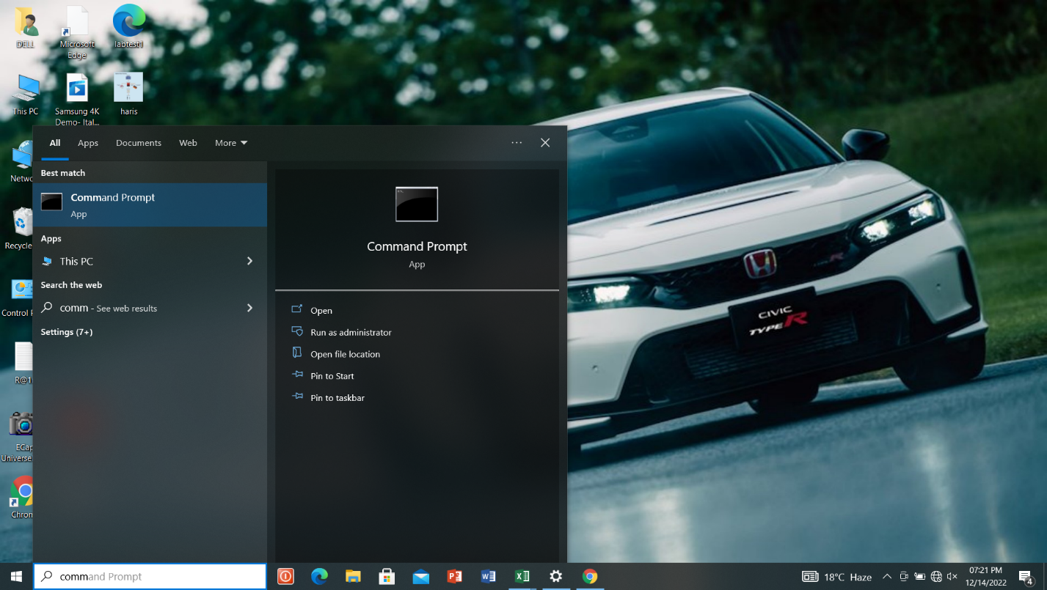

Step#02:
Click on “Command Prompt” and type “inconfig”and then enter

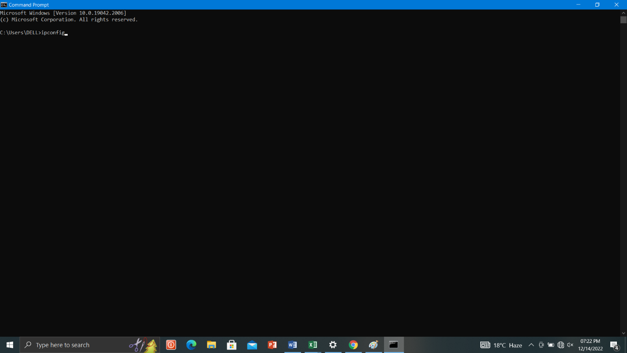

Step#03:
After enter there appears IPv4 address.
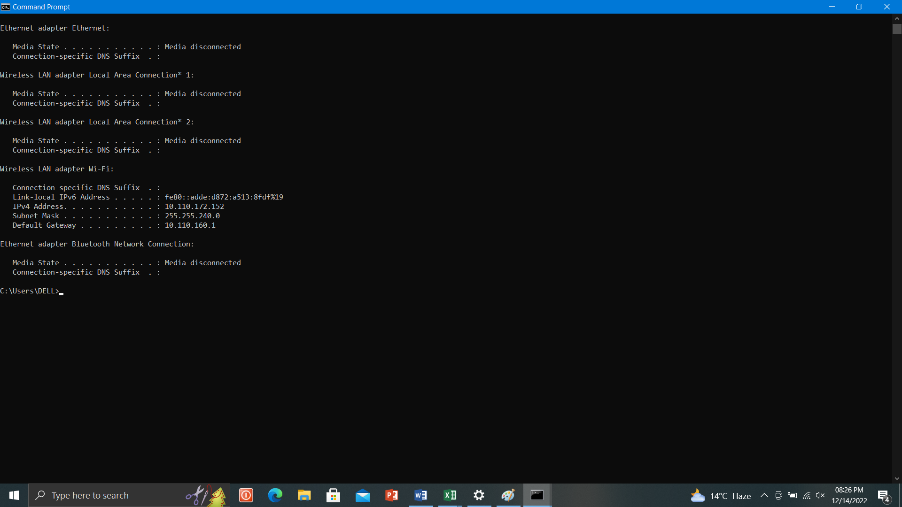

Step#04:
Identify THE IP address of the router. Most routers are manufactured to use a default address such as 192.168.0.1, 192.168.1.1, 192.168.2.1, 192.168.1.100.

Step#05:
In a web browser, such as Microsoft Edge, Internet Explorer, Chrome or Firefox request a connection to the router. Do this by typing the router’s IP address in the browser’s address bar.

Step#06:
Enter the administrative login information-user name and password-to authenticate and access the admin settings.
NOTE:
Some routers are not accessed in the way described here. Most are, but a few require different steps, such as using a mobile app.

Part#02:
Explain how you will send an email with an attachment that has a size more than 30mb.

Step#01:
Upload your file to Google drive.

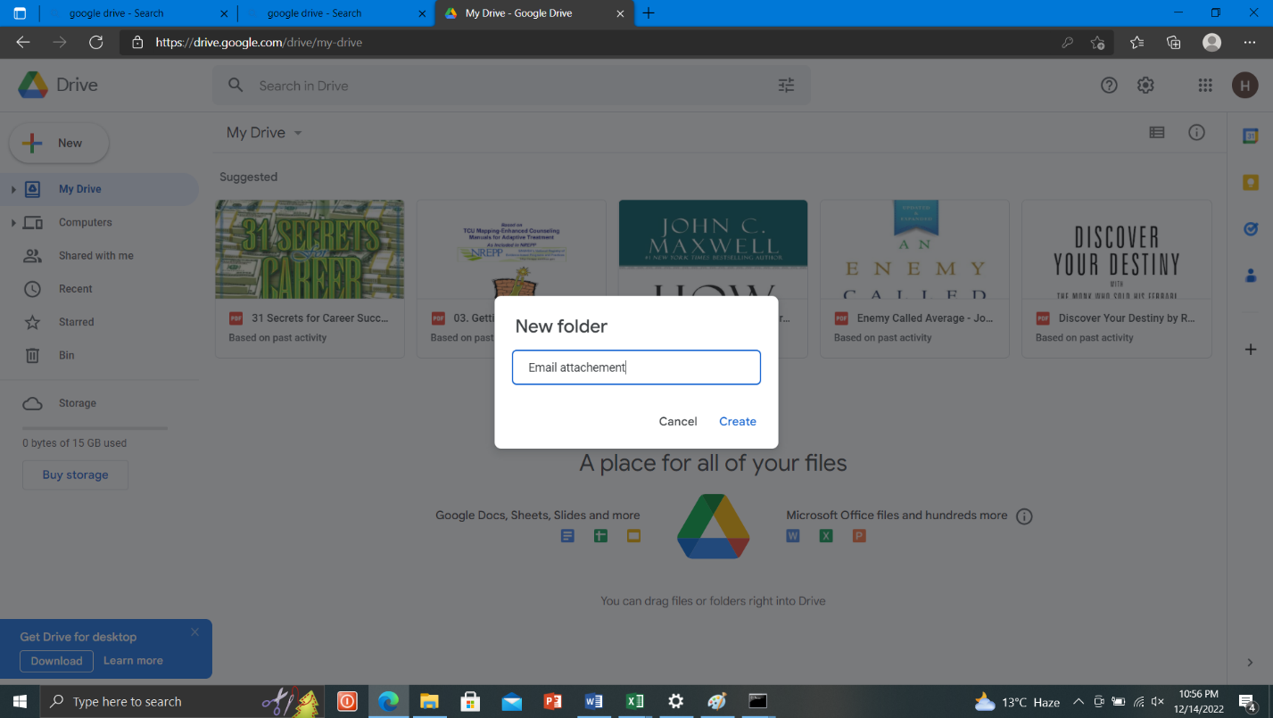

Step#02:
Go to email compose. Write recipient email first.
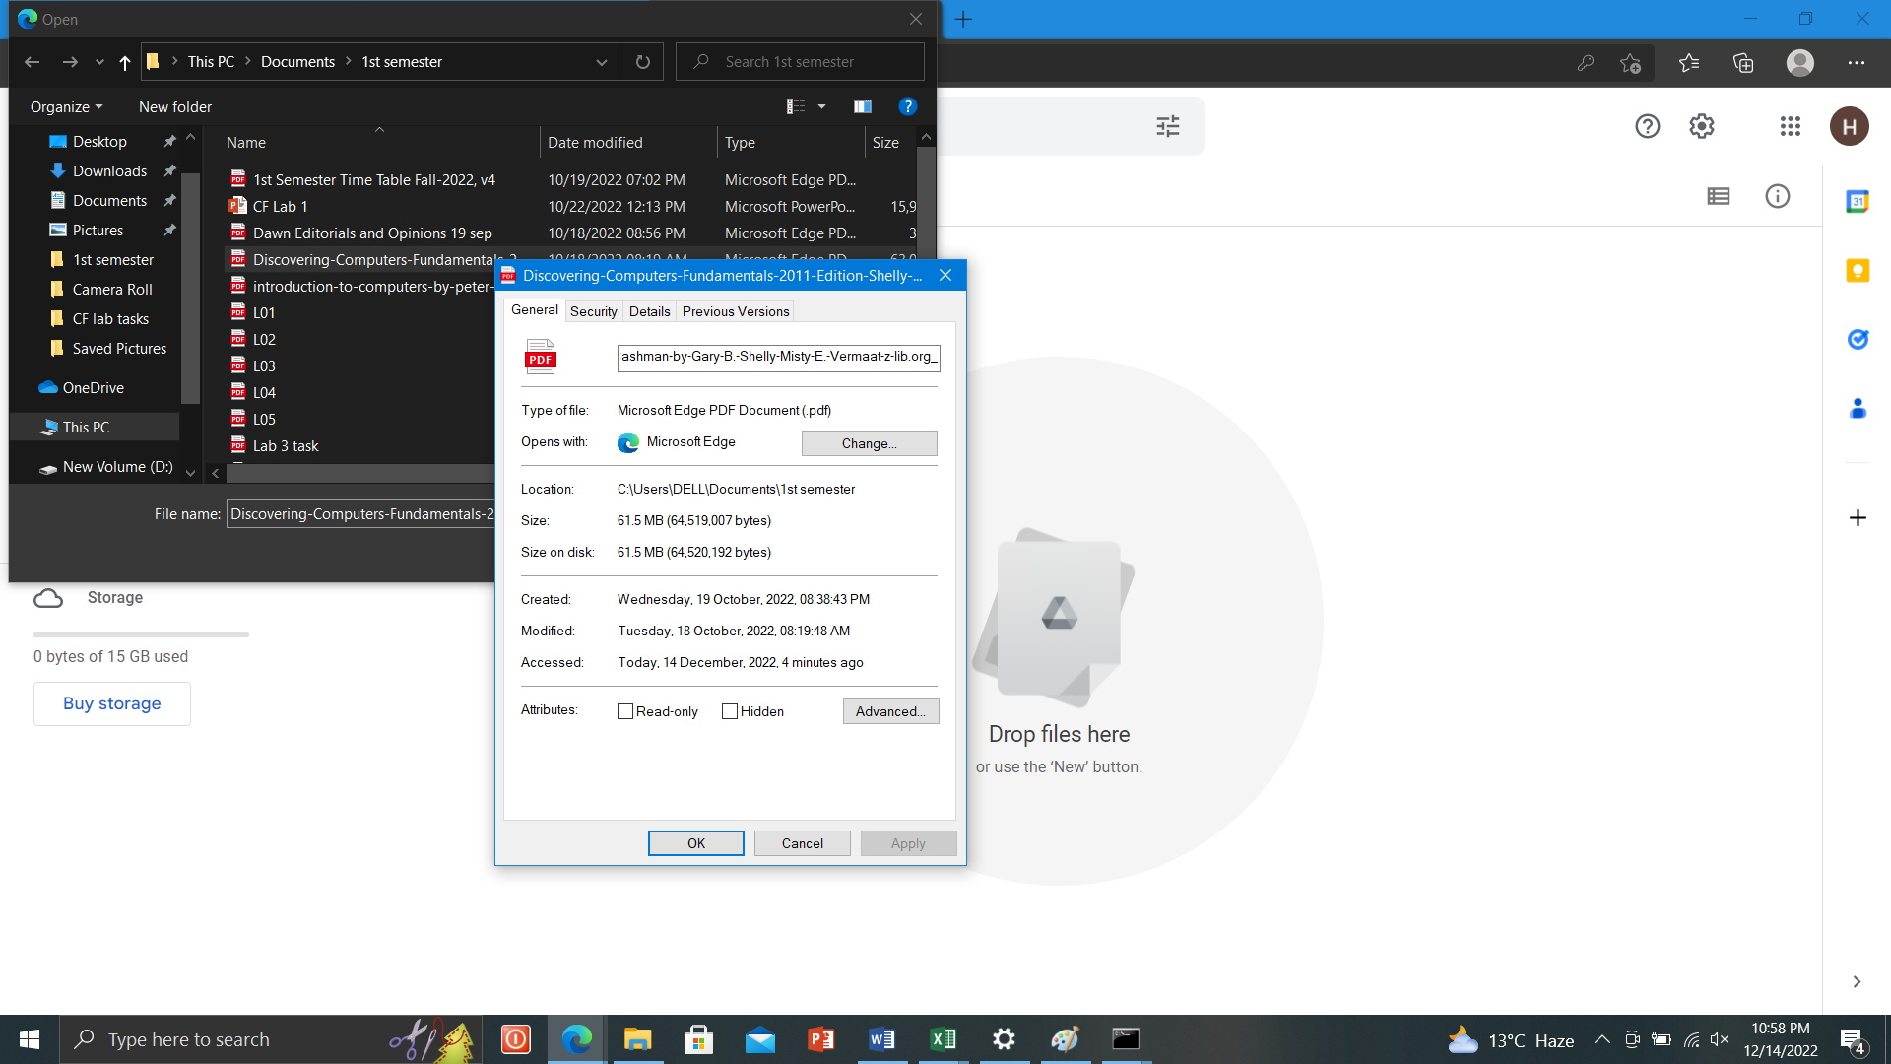

Step#03:
Attach your file from Google drive. Click on insert and then click on send.
